Operating Committee
WebEx Only
October 7, 2021
9:00 a.m. – 2:00 p.m. EDT

Administration (9:00-9:15)
Lauren Strella Wahba, PJM, will provide announcements; review the Antitrust, Code of Conduct, Public Meetings/Media Participation, and the WebEx Participant Identification Requirement.
  - Review and approve draft minutes from the September 10th OC meeting.

  - Review of the OC work plan.

Review of Operations (9:15-9:35)
PJM COVID-19 Update
Paul McGlynn, PJM, will provide an update on PJM’s operations plan in response to COVID-19. https://pjm.com/committees-and-groups/pandemic-coordination.aspx

Review of Operating Metrics
Stephanie Monzon, PJM, will review the September 2021 PJM operating metrics slides. Metrics will include PJM’s load forecast error, BAAL performance, and transmission / generation outage statistics.

Endorsements/Approvals (9:35 – 9:45)
- Manual 01 Attachment F: Control Center and Data Exchange Requirements (MOC Remote Operations)
Chris Moran, PJM, will review Manual 01 Attachment F changes related to Exceptional Circumstances outside of COVID-19. Attachment F is set to expire on December 31, 2021 and the language changes will make Attachment F a permanent part of Manual 01.
The Operating Committee will be asked to endorse these changes at today’s meeting.

First Reading (9:45 – 12:00)
- Manual 03: Transmission Operations
Lagy Mathew, PJM, will review updates to Manual 3: Transmission Operations as a part of the periodic review. The Operating Committee will be asked to endorse these changes at its next meeting.

- Manual 10: Pre-Scheduling Operations
Vince Stefanowicz, PJM, will review updates to Manual 10: Pre-Scheduling Operations as a part of the periodic review.
The Operating Committee will be asked to endorse these changes at its next meeting.

- Manual 14D: Generator Operational Requirements
Vince Stefanowicz, PJM, will review updates to Manual 14D: Generator Operational Requirements as a part of the periodic review.
The Operating Committee will be asked to endorse these changes at its next meeting.

- Manual 13: Emergency Operations
Brian Oakes, PJM, will review updates to Manual 13: Emergency Operations as part of the periodic review.
The Operating Committee will be asked to endorse these changes at its next meeting.

- Day Ahead Schedule Reserve (DASR) Update
David Kimmel, PJM, will review preliminary proposed changes to the 2022 Day Ahead Scheduling
Reserve (DASR) requirement.
The Operating Committee will be asked to endorse the changes at its next meeting.

Winter Weekly Reserve Target Update
Patricio Rocha Garrido, PJM, will review the results of the 2021/22 Winter Weekly Reserve Target
(WWRT) analysis.
The Operating Committee will be asked to endorse the results at its next meeting.

- Synchronous Reserve Deployment Stakeholder Initiative
a. Ilyana Dropkin, PJM, will provide a summary of the Synchronized Reserve Deployment Stakeholder Initiative.

b. Mike Zhang, PJM, will provide a first read of the PJM package that was developed in the SRDTF.
The Operating Committee will be asked to endorse the solution package at its next meeting.

c. Siva Josyula, IMM, will proved a first read of the IMM package that was developed in the SRDTF.
The Operating Committee will be asked to endorse the solution package at its next meeting.

Informational Updates (12:00-2:00)
- System Operations Subcommittee (SOS) Report
Becky Carroll, PJM, will provide a summary of the most recent SOS meeting.

- Cold Weather Preparation Update
Vince Stefanowicz, PJM, will review Generation Resource Cold Weather Preparation activities.

- Reliability Compliance Update
Becky Davis, PJM, will provide an update on NERC, SERC, RFC, and NAESB standards, and other pertinent regulatory and compliance information, and solicit feedback from the members on Reliability Compliance efforts.

- February 2021 Cold Weather Preliminary Report
Dwayne Fewless, ReliabilityFirst, will provide an update on the preliminary findings and recommendations from the February 2021 extreme cold weather event. This preliminary report was the result of a joint inquiry performed by a team of staff from FERC, NERC, and its regional entities.

- Black Start Capital Recovery Factor (“CRF”) Rate Show Cause Proceeding Update
Steve Pincus, PJM, will review PJM’s intended response to FERC’s order issued on August 10, 2021 (“August 10 Order”), establishing a show cause proceeding in Docket No. EL21-91-000, the Black Start Capital Recovery Factor (“CRF”) Rate Order to Show Cause Proceeding.
- Update on PJM Paper Hearing Responses to Cost Allocation Questions From June 25th Order
Jonathan Kern, PJM, will provide an update on when and how PJM plans to respond to the 14 cost allocation questions raised by the Commission in its June 25, 2021 Order that resulted from a complaint filed by Neptune and LIPA on December 31, 2020 related to 20 RTEP projects.

Working Items

Informational Only Postings
- PJM Summer Operations
An informational presentation is available with today’s meeting material on PJM Summer Operations performance. Becky Carroll will be available during the meeting to answer any questions on this material.

OC Subcommittee/ Task Force Informational Section
System Operations Subcommittee (SOS): SOS Website
Data Management Subcommittee (DMS): DMS Website
DER & Inverter-Based Resources Subcommittee (DIRS): DIRS Website
Fuel Requirements for Black Start Resources: Fuel Reqt. for Black Start Resources Issue Tracker
Synchronous Reserve Deployment Task Force: SRDTF Website
IROL – CIP Cost Recovery: IROL – CIP Cost Recovery Issue Tracker

Future Meeting Dates and Materials |  |  | Materials Due  to Secretary | Materials Published
Date | Time | Location | 5 p.m. | 4 p.m.
November 04, 2021 | 9 a.m. | WebEx | October 25, 2021 | October 28, 2021
December 02, 2021 | 9 a.m. | WebEx | November 22, 2021 | November 24, 2021

Author: L. Strella Wahba

Antitrust:
You may not discuss any topics that violate, or that might appear to violate, the antitrust laws including but not limited to agreements between or among competitors regarding prices, bid and offer practices, availability of service, product design, terms of sale, division of markets, allocation of customers or any other activity that might unreasonably restrain competition. If any of these items are discussed the chair will re-direct the conversation. If the conversation still persists, parties will be asked to leave the meeting or the meeting will be adjourned.

Code of Conduct:
As a mandatory condition of attendance at today's meeting, attendees agree to adhere to the PJM Code of Conduct as detailed in PJM Manual M-34 section 4.5, including, but not limited to, participants' responsibilities and rules regarding the dissemination of meeting discussion and materials.

Public Meetings/Media Participation:
Unless otherwise noted, PJM stakeholder meetings are open to the public and to members of the media. Members of the media are asked to announce their attendance at all PJM stakeholder meetings at the beginning of the meeting or at the point they join a meeting already in progress. Members of the Media are reminded that speakers at PJM meetings cannot be quoted without explicit permission from the speaker. PJM Members are reminded that "detailed transcriptional meeting notes" and white board notes from "brainstorming sessions" shall not be disseminated. Stakeholders are also not allowed to create audio, video or online recordings of PJM meetings. PJM may create audio, video or online recordings of stakeholder meetings for internal and training purposes, and your participation at such meetings indicates your consent to the same.
Participant Identification in WebEx:
When logging into the WebEx desktop client, please enter your real first and last name as well as a valid email address. Be sure to select the “call me” option.
PJM support staff continuously monitors WebEx connections during stakeholder meetings. Anonymous users or those using false usernames or emails will be dropped from the teleconference.

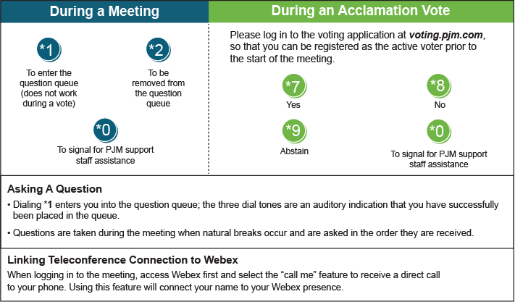

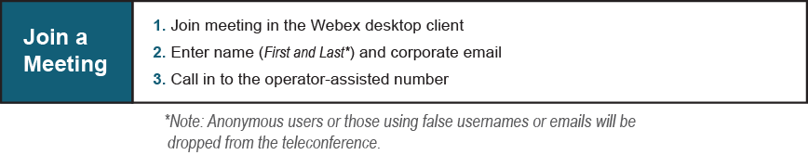
Provide feedback on the progress of this group: Facilitator Feedback Form
Visit learn.pjm.com, an easy-to-understand resource about the power industry and PJM’s role.

