Operating Committee
WebEx Only
September 10, 2021
9:00 a.m. – 12:00 p.m. EDT

Administration (9:00-9:15)
Lauren Strella Wahba, PJM, will provide announcements; review the Antitrust, Code of Conduct, Public Meetings/Media Participation, and the WebEx Participant Identification Requirement.
  - Review and approve draft minutes from the August 12th OC meeting.

  - Review of the OC work plan.

Review of Operations (9:15-9:35)
PJM COVID-19 Update
Paul McGlynn, PJM, will provide an update on PJM’s operations plan in response to COVID-19. https://pjm.com/committees-and-groups/pandemic-coordination.aspx

Review of Operating Metrics
Stephanie Monzon, PJM, will review the August 2021 PJM operating metrics slides. Metrics will include PJM’s load forecast error, BAAL performance, and transmission / generation outage statistics.

Endorsements/Approvals (9:35 – 9:45)
- Manual 14D: Generator Operational Requirements
Terri Esterly, PJM, will review Manual 14D changes related to Behind the Meter Generation (BTMG) Business Rules on Status Changes developed in MIC Special Sessions.
The Operating Committee will be asked to endorse these changes at today’s meeting.

Issue Tracking: Behind the Meter Generation Business Rules on Status Changes

First Reading (9:45 – 10:00)
- Manual 01 Attachment F: Control Center and Data Exchange Requirements (MOC Remote Operations)
Chris Moran, PJM, will review Manual 01 Attachment F changes related to Exceptional Circumstances outside of COVID-19. Attachment F is set to expire on December 31, 2021 and the language changes will make Attachment F a permanent part of Manual 01.
The Operating Committee will be asked to endorse these changes at its next meeting.

Informational Updates (10:00-12:00)
- System Operations Subcommittee (SOS) Report
Becky Carroll, PJM, will provide a summary of the most recent SOS meeting.
- Primary Frequency Response Update
Ilyana Dropkin, PJM, will provide an update on PJM primary frequency response performance.

- Regulation Performance Update
Ilyana Dropkin, PJM, will provide an update on PJM regulation market performance.

- Synchronized Reserve Performance Update
Dave Kimmel, PJM, will provide a review of recent synchronized reserve performance.

- Synchrophasor Update
Eric Hsia, PJM, will review recent activities around PMUs at PJM.

- PPL Dynamic Line Rating Update
Eric Hsia, PJM, will provide and update on the implementation of the PPL Dynamic Line Rating.

- PJM Project Summary
Jim Snow, PJM, will review the Preliminary 2022 Project Budget.

- NERC Lessons Learned
Donnie Bielak, PJM, with review the latest posted NERC Lessons Learned reports.

- Reliability Compliance Update
Becky Davis, PJM, will provide an update on NERC, SERC, RFC, and NAESB standards, and other pertinent regulatory and compliance information, and solicit feedback from the members on Reliability Compliance efforts.

Working Items

Informational Only Postings

OC Subcommittee/ Task Force Informational Section
System Operations Subcommittee (SOS): SOS Website
Data Management Subcommittee (DMS): DMS Website
DER & Inverter-Based Resources Subcommittee (DIRS): DIRS Website
Fuel Requirements for Black Start Resources: Fuel Reqt. for Black Start Resources Issue Tracker
Synchronous Reserve Deployment Task Force: SRDTF Website
IROL – CIP Cost Recovery: IROL – CIP Cost Recovery Issue Tracker

Future Meeting Dates and Materials |  |  | Materials Due  to Secretary | Materials Published
Date | Time | Location | 5 p.m. | 4 p.m.
October 07, 2021 | 9 a.m. | WebEx | September 27, 2021 | September 30, 2021
November 04, 2021 | 9 a.m. | WebEx | October 25, 2021 | October 28, 2021
December 02, 2021 | 9 a.m. | WebEx | November 22, 2021 | November 24, 2021

Author: L. Strella Wahba

Antitrust:
You may not discuss any topics that violate, or that might appear to violate, the antitrust laws including but not limited to agreements between or among competitors regarding prices, bid and offer practices, availability of service, product design, terms of sale, division of markets, allocation of customers or any other activity that might unreasonably restrain competition. If any of these items are discussed the chair will re-direct the conversation. If the conversation still persists, parties will be asked to leave the meeting or the meeting will be adjourned.

Code of Conduct:
As a mandatory condition of attendance at today's meeting, attendees agree to adhere to the PJM Code of Conduct as detailed in PJM Manual M-34 section 4.5, including, but not limited to, participants' responsibilities and rules regarding the dissemination of meeting discussion and materials.

Public Meetings/Media Participation:
Unless otherwise noted, PJM stakeholder meetings are open to the public and to members of the media. Members of the media are asked to announce their attendance at all PJM stakeholder meetings at the beginning of the meeting or at the point they join a meeting already in progress. Members of the Media are reminded that speakers at PJM meetings cannot be quoted without explicit permission from the speaker. PJM Members are reminded that "detailed transcriptional meeting notes" and white board notes from "brainstorming sessions" shall not be disseminated. Stakeholders are also not allowed to create audio, video or online recordings of PJM meetings. PJM may create audio, video or online recordings of stakeholder meetings for internal and training purposes, and your participation at such meetings indicates your consent to the same.
Participant Identification in WebEx:
When logging into the WebEx desktop client, please enter your real first and last name as well as a valid email address. Be sure to select the “call me” option.
PJM support staff continuously monitors WebEx connections during stakeholder meetings. Anonymous users or those using false usernames or emails will be dropped from the teleconference.

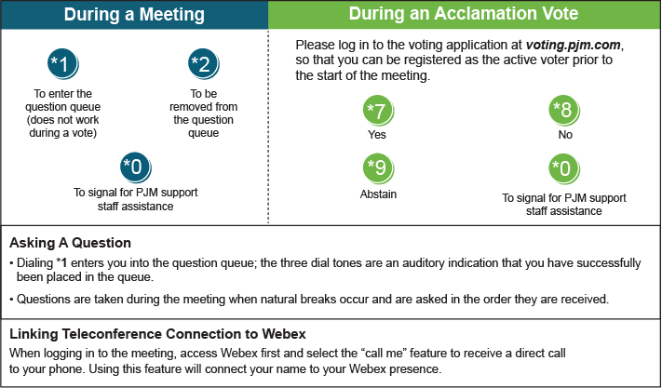

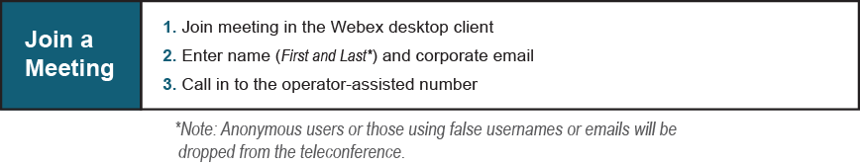
Provide feedback on the progress of this group: Facilitator Feedback Form
Visit learn.pjm.com, an easy-to-understand resource about the power industry and PJM’s role.

