Market Implementation Committee
WebEx Only
February 10, 2021
9:00 a.m. – 4:00 p.m. EPT

Administration (9:00 – 9:05)
Nicholas DiSciullo will review the Antitrust, Code of Conduct, Public Meetings/Media Participation and the WebEx Participant Identification Requirements.

The Committee will be asked to approve the draft minutes from the January 12, 2021 Market Implementation Committee meeting.

Endorsements/Approvals (9:05 – 9:45)
- RPM Capacity Transfer Rights (9:05 – 9:25)
Kevin Zemanek, Buckeye Power will review the Problem Statement and Issue Charge addressing RPM Capacity Transfer Rights.
The committee will be asked to approve the Issue Charge at this meeting.

- Long-Term 5-Minute Dispatch & Pricing Work Plan (9:25 – 9:45)
Aaron Baizman will provide an update on the Long Term Timeline and will review the solution package from the Long-Term Five Minute Dispatch & Pricing Matrix that was worked in MIC Special Session meetings.
The committee will be asked to endorse the PJM/IMM proposal at this meeting.
Issue Tracking: Five Minute Dispatch and Pricing

First Readings (9:45 – 10:30)
- Manual 11 Revisions (9:45 – 10:00)
Nikki Militello will provide a first read of revisions to Manual 11: Energy & Ancillary Service Market Operations as part of the biennial cover-to-cover review. The committee will be asked to endorse the revisions at its next meeting.

- Capital Recovery Factor for Avoidable Project Investment Cost Determinations (10:00 – 10:30)
Jeff Bastian will provide a second first read of the Problem Statement and Issue Charge addressing Capital Recovery Factor for Avoidable Project Investment Cost Determinations.
The committee will be asked to approve the issue charge and endorse the solution as part of the Quick Fix process outlined in Section 8.6.1 of Manual 34 at its next meeting.

Working Items (10:30 - 11:15)
- Market Suspension (10:30 – 11:00)
- Lisa Morelli will facilitate a discussion on the Market Suspension matrix as part of the Consensus Based Issue Resolution process.
- Stefan Starkov will provide education supporting PJM’s proposed solution options.
Issue Tracking: Rules Related to Market Suspension

- Transparency in Performance Assessment Interval Settlements (11:00 – 11:15)
Susan Kenney will review draft Manual 18: PJM Capacity Market clarifying language associated with two of the areas identified as needing additional transparency in PAI Settlements, both related to resource modeling.
Issue Tracking: Transparency in Performance Assessment Interval (PAI) Settlements

Additional Items – Part 1 (11:15 – 12:10)
- PPL Dynamic Line Ratings (11:15 – 11:25)
Shaun Murphy will provide an update on recent Dynamic Line Ratings discussions and PJM’s plans to track and coordinate future stakeholder discussions.

- 2021/22 ARR/FTR Update (11:25 – 11:35)
Emmy Messina will review the ARR/FTR modeling processes completed to date and upcoming deadlines for the 2021/2022 planning year.

- Incremental Auction Revenue Rights for RTEP Upgrades (11:35 – 11:45)
Xu Xu will provide an update on Incremental Auction Revenue Rights for upgrades in the Regional Transmission Expansion Plan for the 2021/2022 planning year.

- Elgin Energy Center and Kincaid SPS/RAS Retirement (11:45 – 11:55)
Alan Engelmann, ComEd, will review the retirement of the Elgin Energy Center and Kincaid Special Protection Systems (SPS) and Remedial Action Schemes (RAS).

- Cost Development Subcommittee (11:55 – 12:10)
Nicole Scott will provide an overview of the work plan for the recently re-chartered Cost Development Subcommittee.

Lunch (12:10 – 12:40)

Additional Items – Part 2 (12:40 – 2:00)
- Fast Start Pricing Order Overview (12:40 – 1:40)
Vijay Shah and Rebecca Stadelmeyer will provide details of PJM’s Fast Start Pricing compliance filing for docket ER19-2722.

- Reactive Power in PJM (1:40 – 2:00)
Thomas DeVita will provide an overview of Reactive Power compensation in PJM, its history and comparison to practices at other ISOs and RTOs.

Informational Section
Q4 2020 Net Energy Injections Quarterly Report
Materials are posted as informational only.

CP Unit Specific Parameter Update
Materials are posted as informational only.

Interregional Coordination Update
Materials are posted as informational only.

ARR FTR Market Task Force (AFMTF)
Meeting materials are posted to the AFMTF website.

Cost Development Subcommittee (CDS)
Meeting materials are posted to the CDS website.

Demand Response Subcommittee (DRS)
Meeting materials are posted to the DRS website.

DER & Inverter-based Resources Subcommittee (DIRS)
Meeting materials are posted to the DIRS website.

Market Settlements Subcommittee (MSS)
Meeting materials are posted to the MSS website.

Report on Market Operations
The Report on Market Operations will be reviewed during the MC Webinar.

Future Meeting Dates
March 10, 2021 | 9:00 a.m. | WebEx
April 7, 2021 | 9:00 a.m. | WebEx
May 13, 2021 | 9:00 a.m. | WebEx
June 9, 2021 | 9:00 a.m. | WebEx
July 14, 2021 | 9:00 a.m. | WebEx
August 11, 2021 | 9:00 a.m. | WebEx
September 9, 2021 | 9:00 a.m. | WebEx
October 6, 2021 | 9:00 a.m. | WebEx
November 3, 2021 | 9:00 a.m. | WebEx
December 1, 2021 | 9:00 a.m. | WebEx

Author: Nick DiSciullo

Antitrust:
You may not discuss any topics that violate, or that might appear to violate, the antitrust laws including but not limited to agreements between or among competitors regarding prices, bid and offer practices, availability of service, product design, terms of sale, division of markets, allocation of customers or any other activity that might unreasonably restrain competition. If any of these items are discussed the chair will re-direct the conversation. If the conversation still persists, parties will be asked to leave the meeting or the meeting will be adjourned.

Code of Conduct:
As a mandatory condition of attendance at today's meeting, attendees agree to adhere to the PJM Code of Conduct as detailed in PJM Manual M-34 section 4.5, including, but not limited to, participants' responsibilities and rules regarding the dissemination of meeting discussion and materials.

Public Meetings/Media Participation:
Unless otherwise noted, PJM stakeholder meetings are open to the public and to members of the media. Members of the media are asked to announce their attendance at all PJM stakeholder meetings at the beginning of the meeting or at the point they join a meeting already in progress. Members of the Media are reminded that speakers at PJM meetings cannot be quoted without explicit permission from the speaker. PJM Members are reminded that "detailed transcriptional meeting notes" and white board notes from "brainstorming sessions" shall not be disseminated. Stakeholders are also not allowed to create audio, video or online recordings of PJM meetings. PJM may create audio, video or online recordings of stakeholder meetings for internal and training purposes, and your participation at such meetings indicates your consent to the same.
Participant Identification in WebEx:
When logging into the WebEx desktop client, please enter your real first and last name as well as a valid email address. Be sure to select the “call me” option.
PJM support staff continuously monitors WebEx connections during stakeholder meetings. Anonymous users or those using false usernames or emails will be dropped from the teleconference.
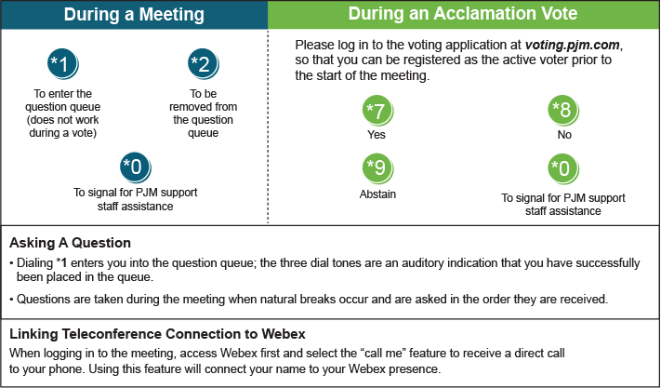

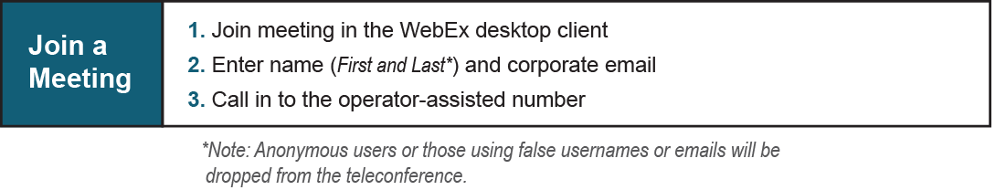
Provide feedback on the progress of this group: Facilitator Feedback Form
Visit learn.pjm.com, an easy-to-understand resource about the power industry and PJM’s role.

