Market Implementation Committee
PJM Conference & Training Center, Audubon, PA
January 8, 2020
9:00 a.m. – 4:00 p.m. EPT

Administration (9:00-9:05)
- Ms. Bhavana Keshavamurthy, PJM, will provide announcements; review the Antitrust, Code of Conduct, Public Meetings/Media Participation, the WebEx Participant Identification Requirement, and Issue Tracking.

The Committee will be asked to approve the draft minutes from the December 11, 2019 Market Implementation Committee meeting.

First Readings (9:05-9:25)
- Synchronized Reserve Variable Operation and Maintenance Cost (9:05-9:25)
Ms. Catherine Tyler, Monitoring Analytics, will review a problem statement and issue charge associated with the allowable level of variable operations and maintenance costs in synchronized reserve offers. The committee will be asked to approve the issue charge and endorse the proposed revisions to Manual 15: Cost Development Guidelines as part of the Quick Fix process outlined in Section 8.6.1 of Manual 34 at its next meeting.

Additional Items (9:25-12:00)
- Update on PJM March 11 FERC filing on Capacity Market Capability of Energy Storage Resources (9:25-9:45)
Mr. Andrew Levitt, PJM, will provide an update on the process to prepare PJM’s brief to FERC on the Capability of Capacity Storage Resources in Docket EL19-100, due March 11, 2020.

- Capacity Market Minimum Offer Price Rule (MOPR) Order (9:45-12:00)
- Mr. Adam Keech, PJM, will provide an overview of the order FERC issued in Dockets EL16-49 and EL18-178 on December 19, 2020.
- Mr. Paul Scheidecker, PJM, will provide an overview of the pre-auction activities associated with running a Base Residual Auction.
- Mr. Pat Bruno, PJM, will provide education on the existing rules surrounding election of the Fixed Resource Requirement Alternative.

Lunch (12:00-12:45)

Additional Items (12:45-3:45)
- Capacity Market Minimum Offer Price Rule (MOPR) Order (Continued)
- Ms. Lisa Morelli, PJM, will facilitate a discussion sharing stakeholder perspectives on the order’s impact on their organization in the following order:
  - LS Power
  - Vistra Energy
  - Old Dominion Electric Cooperative(ODEC)
  - Exelon
  - PJM Power Providers
  - EDP Renewables
  - Avangrid Renewables
  - Advanced Energy Management Alliance (AEMA)
  - American Petroleum Institute(API)
  - Lightsource BP (LSBP)
  - American Municipal Power
  - PSEG
  - Advanced Energy Economy (AEE) + Advanced Energy Buyers Group (AEBG)
  - American Wind Energy Association(AWEA) + Solar Energy Industries Association (SEIA)
  - Calpine Energy Services

Informational Section
Note: Discussions on the Stability Limits in Markets and Operations agenda item will resume at the February MIC.

CP Unit Specific Parameter Update
Materials are posted as informational only.

Credit Subcommittee (CS)
Meeting materials will be posted to the CS website.

Demand Response Subcommittee (DRS)
Meeting materials will be posted to the DRS web site.

Intermittent Resources Subcommittee (IRS)
Meeting materials will be posted to the IRS web site.

Market Settlements Subcommittee (MSS)
Meeting materials are posted to the MSS web site.

Report on Market Operations
The Report on Market Operations will be reviewed during the MC Webinar.

Future Meeting Dates
February 5, 2020 | 9:00 a.m. | PJM Conference & Training Center/ WebEx
March 11, 2020 | 9:00 a.m. | PJM Conference & Training Center/ WebEx
April 15, 2020 | 9:00 a.m. | PJM Conference & Training Center/ WebEx
May 13, 2020 | 9:00 a.m. | PJM Conference & Training Center/ WebEx
June 3, 2020 | 9:00 a.m. | PJM Conference & Training Center/ WebEx
Author: Bhavana Keshavamurthy

Antitrust:
You may not discuss any topics that violate, or that might appear to violate, the antitrust laws including but not limited to agreements between or among competitors regarding prices, bid and offer practices, availability of service, product design, terms of sale, division of markets, allocation of customers or any other activity that might unreasonably restrain competition. If any of these items are discussed the chair will re-direct the conversation. If the conversation still persists, parties will be asked to leave the meeting or the meeting will be adjourned.

Code of Conduct:
As a mandatory condition of attendance at today's meeting, attendees agree to adhere to the PJM Code of Conduct as detailed in PJM Manual M-34 section 4.5, including, but not limited to, participants' responsibilities and rules regarding the dissemination of meeting discussion and materials.

Public Meetings/Media Participation:
Unless otherwise noted, PJM stakeholder meetings are open to the public and to members of the media. Members of the media are asked to announce their attendance at all PJM stakeholder meetings at the beginning of the meeting or at the point they join a meeting already in progress. Members of the Media are reminded that speakers at PJM meetings cannot be quoted without explicit permission from the speaker. PJM Members are reminded that "detailed transcriptional meeting notes" and white board notes from "brainstorming sessions" shall not be disseminated. Stakeholders are also not allowed to create audio, video or online recordings of PJM meetings. PJM may create audio, video or online recordings of stakeholder meetings for internal and training purposes, and your participation at such meetings indicates your consent to the same.
Participant Identification in WebEx:
When logging into the WebEx desktop client, please enter your real first and last name as well as a valid email address. Be sure to select the “call me” option.
PJM support staff continuously monitors WebEx connections during stakeholder meetings. Anonymous users or those using false usernames or emails will be dropped from the teleconference.

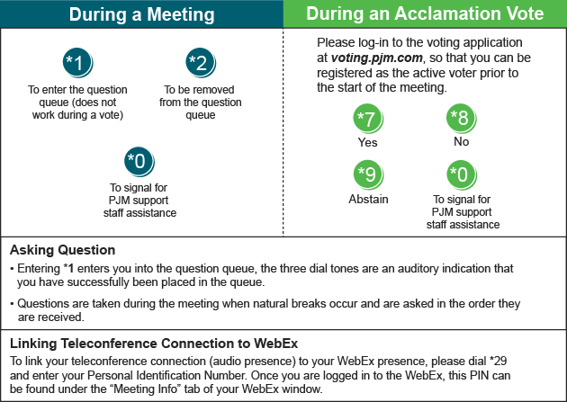

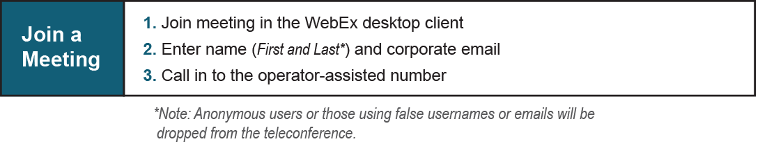
Provide feedback on the progress of this group: Facilitator Feedback Form
Visit learn.pjm.com, an easy-to-understand resource about the power industry and PJM’s role.

