Market Implementation Committee
PJM Conference & Training Center, Audubon, PA
August 7, 2019
9:00 a.m. – 4:00 p.m. EPT

Administration (9:00-9:15)
Ms. Bhavana Keshavamurthy and Ms. Lisa Morelli will provide announcements; review the Antitrust, Code of Conduct, Public Meetings/Media Participation, the WebEx Participant Identification Requirement, and Issue Tracking.

The Committee will be asked to approve the draft minutes from the July 10, 2019 Market Implementation Committee meeting.

        - Mr. Pat Bruno, PJM, will provide an update on the recent FERC order directing PJM to postpone the 2022/2023 Base Residual Auction (BRA).

Endorsements/Approvals (9:15-11:00)
- Manual 11 revisions (9:15-9:30)
Mr. Michael Olaleye, PJM, will provide an overview of clarifications being added to Manual 11: Energy & Ancillary Services associated with regulation historical performance scores and reserve requirements.
The committee will be asked to endorse the manual revisions.

- Manual 18B revisions( 9:30-9:45)
Ms. Terri Esterly, PJM, will review proposed revisions to Manual 18B: Energy Efficiency Measurement & Verification resulting from the periodic review which includes administrative updates and conforming revisions to FERC orders. Ms.Esterly will be seeking endorsement of these manual revisions at first read.
The committee will be asked to endorse the manual revisions.

- Manual 27 and 28 revisions for Electric Storage Participation – FERC Order 841(9:45-10:00)
Ms. Laura Walter, PJM, will provide a review of Manual 27: Open Access Transmission Tariff Accounting and Manual 28: Operating Agreement Accounting revisions associated with settlements changes related to FERC Order 841 compliance filing.
The committee will be asked to endorse the manual revisions.
Issue Tracking: Electric Storage Participation FERC Order 841

- Modeling Units with Stability Limitations – Problem Statement & Issue Charge (10:00-10:15)
Mr. Robert O’Connell, Panda Power Funds, will provide an overview of the problem statement and issue charge related to modeling units with stability limitations.
The committee will be asked to approve the issue charge.

- Load Management Testing Requirements Issue Charge Modification (10:15-10:30)
Mr.Pete Langbein, PJM, will review the modifications to the Load Management Testing Requirements Issue Charge to include Price Responsive Demand (PRD) Testing. Mr. Langbein will be seeking approval of the modified issue charge at first read.
The committee will be asked to approve the modified issue charge.
Issue Tracking: Load Management Testing Requirements

- Opportunity Cost Calculator (10:30-11:00)
Mr. Glen Boyle, PJM, will provide summary of the work done by the MIC Special Sessions: Opportunity Cost Calculator. Mr. Robert O’Connell, Panda Power Funds, will provide a summary of the three Panda/Dominion proposals.
The committee will be asked to vote on each of the Panda/Dominion proposals. If any of the proposals receives greater than 50%, a second non-binding vote will be taken asking whether participants prefer the option with the highest percentge in favor greater than 50% over the status quo.
Issue Tracking: Opportunity Cost Calculator

First Readings (11:00-1:00)
- Gas Contingency Cost Recovery (11:00- 11:30)
Mr. Thomas DeVita, PJM, will provide an overview of draft Tariff revisions associated with gas contingencies cost recovery.

- Load Management Testing Requirements (11:30-12:15)
Mr. Pete Langbein, PJM, will provide a first read of the five Load Management Test proposals developed at the Demand Response Subcommittee.
Issue Tracking: Load Management Testing Requirements

Lunch (12:15-1:00)

Working Issues (1:00-3:00)
- Five Minute Dispatch and Pricing (1:00-2:00)
        - Ms. Catherine Tyler, Monitoring Analytics, will present education on LPC execution timeline, use of approved RT SCED cases, target interval difference, and its impact on energy and reserve settlements.
        - Mr.Vijay Shah, PJM, will present education on the Locational Pricing Calculator (LPC) engine.

- Fast Start Pricing Compliance Filing Details (2:00-2:45)
        - Mr. Ray Fernandez, PJM, will review changes to the lost opportunity cost credit calculations related to the implementation of fast start pricing.
        - A summary document listing all the filings related to Fast Start Pricing will be posted as an informational item.

- Interregional Incremental Auction Revenue Rights (2:45-3:00)
Mr. Brian Chmielewski, PJM, will review the Interregional Incremental Auction Revenue Rights (IARR) issue and present a path forward. Members are encouraged to review the posted materials and provide additional proposals to the FTRGroup@pjm.com.
Issue Tracking: Interregional Incremental Auction Revenue Rights

Additional Updates (3:00-3:05)
- FERC Order 844 Updates(3:00-3:05)
Mr. Rami Dirani, PJM, will provide an update on the additional uplift data postings that will be available due to the approval of FERC Order 844.

Informational Section
Credit Subcommittee (CS)
Meeting materials will be posted to the CS website.

Demand Response Subcommittee (DRS)
Meeting materials will be posted to the DRS web site.

Intermittent Resources Subcommittee (IRS)
Meeting materials will be posted to the IRS web site.

Net Energy Injections Quarterly Report
Materials are posted as informational only.

Interregional Coordination Update
Materials are posted as informational only.

Market Settlements Subcommittee (MSS)
Meeting materials are posted to the MSS web site.

Report on Market Operations
The Report on Market Operations will be reviewed during the MC Webinar.

PJM Manual 03 Attachment E Automatic Sectionalizing Schemes
Materials are posted as informational only.

Future Meeting Dates
September 11, 2019 | 9:00 a.m. | PJM Conference & Training Center/ WebEx
October 16, 2019 | 9:00 a.m. | PJM Conference & Training Center/ WebEx
November 13, 2019 | 9:00 a.m. | PJM Conference & Training Center/ WebEx
December 11, 2019 | 9:00 a.m. | PJM Conference & Training Center/ WebEx

Author: Bhavana Keshavamurthy

Antitrust:
You may not discuss any topics that violate, or that might appear to violate, the antitrust laws including but not limited to agreements between or among competitors regarding prices, bid and offer practices, availability of service, product design, terms of sale, division of markets, allocation of customers or any other activity that might unreasonably restrain competition. If any of these items are discussed the chair will re-direct the conversation. If the conversation still persists, parties will be asked to leave the meeting or the meeting will be adjourned.

Code of Conduct:
As a mandatory condition of attendance at today's meeting, attendees agree to adhere to the PJM Code of Conduct as detailed in PJM Manual M-34 section 4.5, including, but not limited to, participants' responsibilities and rules regarding the dissemination of meeting discussion and materials.

Public Meetings/Media Participation:
Unless otherwise noted, PJM stakeholder meetings are open to the public and to members of the media. Members of the media are asked to announce their attendance at all PJM stakeholder meetings at the beginning of the meeting or at the point they join a meeting already in progress. Members of the Media are reminded that speakers at PJM meetings cannot be quoted without explicit permission from the speaker. PJM Members are reminded that "detailed transcriptional meeting notes" and white board notes from "brainstorming sessions" shall not be disseminated. Stakeholders are also not allowed to create audio, video or online recordings of PJM meetings. PJM may create audio, video or online recordings of stakeholder meetings for internal and training purposes, and your participation at such meetings indicates your consent to the same.

Participant Identification in WebEx:
When logging into the WebEx desktop client, please enter your real first and last name as well as a valid email address. Be sure to select the “call me” option.
PJM support staff continuously monitors WebEx connections during stakeholder meetings. Anonymous users or those using false usernames or emails will be dropped from the teleconference.

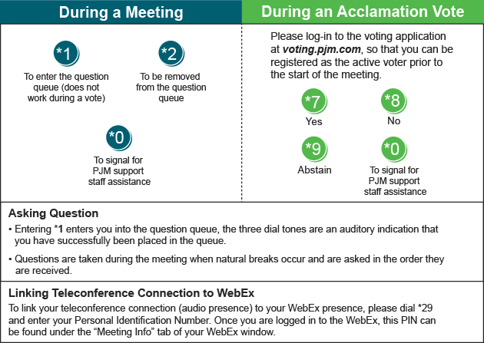

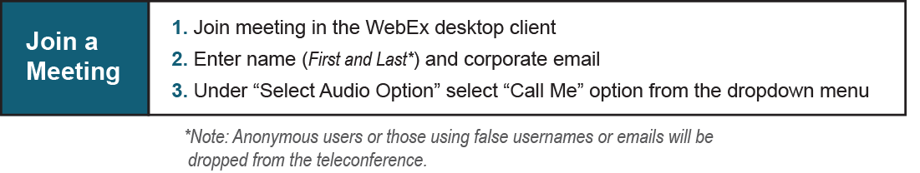

Provide feedback on the progress of this group: Facilitator Feedback Form
Visit learn.pjm.com, an easy-to-understand resource about the power industry and PJM’s role.

