Market Implementation Committee
PJM Conference & Training Center, Audubon, PA
July 11, 2018
9:00 a.m. – 4:00 p.m. EPT

Administration (9:00-9:15)
Ms. Bhavana Keshavamurthy and Ms. Chantal Hendrzak will provide announcements; review the Antitrust, Code of Conduct, Public Meetings/Media Participation, the WebEx Participant Identification Requirement, and Issue Tracking.
  - EL05-121 Settlement Agreement
A. Mr. Ray Fernandez, PJM, will provide an update on the settlements impacts of FERC EL05-121-009.
The Committee will be asked to approve the draft minutes from the June 6, 2018 MIC meeting.

Endorsements/Approvals (9:15-10:00)
- Governing Document Revisions for Seasonal Demand Response Registration (9:15-9:30)
Ms. Andrea Yeaton, PJM, and Ms. Terri Esterly, PJM, will review revisions to Manual 18: PJM Capacity Market, the Open Access Transmission Tariff (OATT) and the Reliability Assurance Agreement (RAA) associated with the registration process for aggregated seasonal Demand Response resources. The Committee will be asked to endorse the revisions.
Issue Tracking: Seasonal Demand Response Registration

- FTR Credit Proposal (9:30-10:00)
Ms. Bridgid Cummings, PJM, will review two FTR Credit proposals developed at the Credit Subcommittee (CS), and the associated OATT revisions. The Committee will be asked to endorse a proposal.
Issue Tracking: FTR Credit Enhancements

First Readings (10:00-10:45)
- Market Seller Offer Cap Balancing Ratio Proposal (10:00-10:45)
Mr. Pat Bruno, PJM, will present a first read of two draft proposals to address the Offer Cap Balancing Ratio issue. Stakeholders will be given an opportunity to include additional packages for consideration. The Committee will be asked to endorse a proposal at the August MIC.
Issue Tracking: Balancing Ratio Determination

Working Issues (10:45-4:00)
- FERC Order 831 – Offer Caps (10:45-11:45)
Ms. Susan Kenney, PJM, will provide more information regarding Price-Based Offers greater than $1,000/MWh as requested at the May 24 MRC meeting.

Working Lunch (11:45-12:00)

- Quadrennial Review (12:00-1:00)
Mr. Gary Helm, PJM, will present follow-up items from the July 6 Quadrennial Review Special Session, and review the Matrix.

- Variable Operations & Maintenance (VOM) Costs (1:00-4:00)
VOM packages will be reviewed by package sponsors in the order in which they will be voted on at the MRC for endorsement.
- Mr. Brock Ondayko, AEP will review the VOM default package which included the friendly amendment endorsed at the June MRC.
- Ms. Melissa Pilong, PJM will review the PJM VOM package
- Dr. Catherine Tyler, Monitoring Analytics, and Mr. Joel Luna, Monitoring Analytics, will review the IMM package.
- Mr.Brian Wilkie, RECO will review the RECO VOM package.

Additional Updates
The remaining agenda items are posted as informational-only. If time permits, the items below will be presented following discussion of the MIC working issues. Otherwise the listed presenter will be available for questions associated with their agenda item.

- FERC Order 844: Uplift Cost Allocation and Transparency
Mr. Rami Dirani, PJM, will provide a summary of FERC Order 844, and PJM’s implementation plan.
Issue Tracking: Market Operations Price Transparency

- Must Offer Exception Process
Mr. Pat Bruno, PJM, will review the Must Offer Exception Process issue, and Stakeholders feedback to include additional options and packages for consideration will be requested.
Issue Tracking: Must Offer Exemption Process

- FTR Forfeiture Rule
Mr. Brian Chmielewski, PJM, will review the FTR Forfeiture Rule issue. A FTR Forfeiture Rule Matrix has been posted and members are encouraged to review and provide additional interests and design components to FTRGroup@pjm.com.
Issue Tracking: FTR Forfeiture Rule Changes

- Problem Statement & Issue Charge – Fuel Requirements for Black Start Resources
Mr. David Schweizer, PJM, will review problem statement and issue charge to address Fuel Requirements for Black Start Resources. This issue will be worked in conjunction with the Operating Committee (OC).

- PJM.com Data Retirements
Mr. Tom Zadlo, PJM, will provide an update on Data Retirements on pjm.com.

- Dominion Carolina 54 RAS/SPS Retirement
Mr. Craig Crider, Dominion, will be presenting the retirement of the Carolina 54 RAS/SPS.

Informational Section
Credit Subcommittee (CS)
Meeting materials will be posted to the CS website.

Demand Response Subcommittee (DRS)
Meeting materials will be posted to the DRS web site.

Intermittent Resources Subcommittee (IRS)
Meeting materials will be posted to the IRS web site.

Interregional Coordination Update
Materials are posted as informational only.

Market Settlements Subcommittee (MSS)
Meeting materials are posted to the MSS web site.

Report on Market Operations
The Report on Market Operations will be reviewed during the MC Webinar.

Future Meeting Dates
August 8, 2018 | 9:00 a.m. | PJM Conference & Training Center/ WebEx
September 12, 2018 | 9:00 a.m. | PJM Conference & Training Center/ WebEx
October 10, 2018 | 9:00 a.m. | PJM Conference & Training Center/ WebEx
November 7, 2018 | 9:00 a.m. | PJM Conference & Training Center/ WebEx
December 12, 2018 | 9:00 a.m. | PJM Conference & Training Center/ WebEx

Author: Bhavana Keshavamurthy

Antitrust:
You may not discuss any topics that violate, or that might appear to violate, the antitrust laws including but not limited to agreements between or among competitors regarding prices, bid and offer practices, availability of service, product design, terms of sale, division of markets, allocation of customers or any other activity that might unreasonably restrain competition. If any of these items are discussed the chair will re-direct the conversation. If the conversation still persists, parties will be asked to leave the meeting or the meeting will be adjourned.

Code of Conduct:
As a mandatory condition of attendance at today's meeting, attendees agree to adhere to the PJM Code of Conduct as detailed in PJM Manual M-34 section 4.5, including, but not limited to, participants' responsibilities and rules regarding the dissemination of meeting discussion and materials.

Public Meetings/Media Participation:
Unless otherwise noted, PJM stakeholder meetings are open to the public and to members of the media. Members of the media are asked to announce their attendance at all PJM stakeholder meetings at the beginning of the meeting or at the point they join a meeting already in progress. Members of the Media are reminded that speakers at PJM meetings cannot be quoted without explicit permission from the speaker. PJM Members are reminded that "detailed transcriptional meeting notes" and white board notes from "brainstorming sessions" shall not be disseminated. Stakeholders are also not allowed to create audio, video or online recordings of PJM meetings. PJM may create audio, video or online recordings of stakeholder meetings for internal and training purposes, and your participation at such meetings indicates your consent to the same.

Participant Identification in WebEx:
When logging into the WebEx desktop client, please enter your real first and last name as well as a valid email address. Be sure to select the “call me” option.
PJM support staff continuously monitors WebEx connections during stakeholder meetings. Anonymous users or those using false usernames or emails will be dropped from the teleconference.

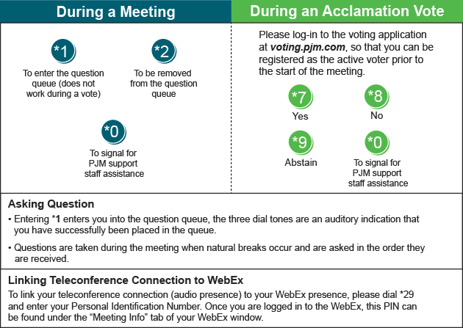

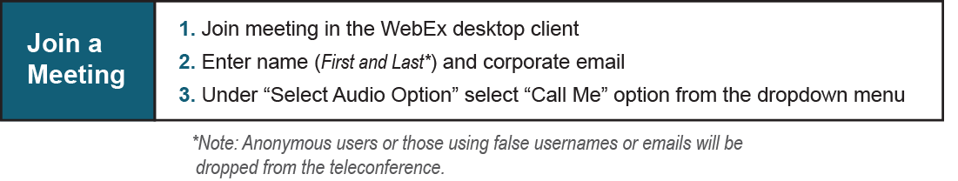

Provide feedback on the progress of this group: Facilitator Feedback Form
Visit learn.pjm.com, an easy-to-understand resource about the power industry and PJM’s role.

