Dr. Ake Almgren
Chair, PJM Board of Managers
PJM Interconnection, LLC
2750 Monroe Boulevard
Audubon, Pennsylvania 19403

January 30, 2019
Re: February 11, 2019 Liaison Committee Meeting Final Agenda
Dear Dr. Almgren:
The Members of the Liaison Committee (“LC”) and I greatly appreciate the Board of Managers’ (“Board”) January 17, 2019 correspondence offering support for the proposed Energy Price Formation agenda topic. We have agreed to delay to a future Liaison Committee, most likely the April 3, 2019 meeting, a discussion on the GreenHat Default stemming from the findings of the report being prepared by the third-party experts to the Special Committee.
With over 60 days between this letter and the April 3rd LC meeting, we are requesting that the Board please endeavor to schedule their time in such a way as to provide an additional 30 minutes to meet with the LC in April. Given our mutual agreement today to delay the GreenHat discussion to allow for a robust discussion of that item as well as any others that will be on the agenda we believe a limited extension of the meeting time is warranted. Moreover, the Members of the LC are requesting that in lieu of a GreenHat Default agenda item at the February 11th LC meeting that you or any other Board member please offer some limited comments during the Opening Remarks to address at least the following questions:
- All sectors agree this should be a transparent process and to that end in addition to whatever report is posted from the Board, stakeholders request the consultants’ report be made public as well. Does the Board agree?
- When does the Special Committee anticipate receiving the report from the third-party experts?
- How will PJM distribute the report to the Members and will there be a special stakeholder meeting scheduled to discuss the report?
- Did the investigators deliver document requests to anyone during the investigation?

We agree to strictly limit any responses to clarifying questions only and for a maximum of 10 minutes.

* * *
AGENDA
- Opening Remarks (20 minutes)

- Energy Price Formation (90 minutes)

The LC discussed this issue at the July 27, 2017 LC meeting based on PJM’s June 15, 2017 PJM Energy Price Formation and Valuing Flexibility whitepaper. Since that time, the PJM stakeholders approved the creation of the Energy Price Formation Senior Task Force on December 21, 2017.
On April 11, 2018, PJM’s President and CEO circulated a letter (link) to the Members noting that the Board requested stakeholders “to deliberate timely and work to develop the details of market rule changes to address those components of the reserve procurement and pricing issues” by the third quarter of 2018. The letter included an additional request for “stakeholders to continue work to develop the details of the remaining components of the reserve procurement and pricing issues by the first quarter of 2019 for Board action, filing with FERC and implementing the proposal by the summer of 2019.”
On December 5, 2018, the Members received a letter from you (link) noting that the “Task Force was unable to reach a consensus solution by the third quarter of 2018” and that, therefore, “the Board has directed PJM management to work with the stakeholders” to identify components of a six-part comprehensive package “on which consensus can be reached by January 31st of 2019.”
The LC wishes to discuss the various components of the Board’s proposed package. Additionally, individual sectors may wish to discuss alternative proposals under consideration.
The LC also would like to better understand the Board’s perspective on the PJM stakeholder process that led the Board to “direct PJM management to make a Section 206 filing” if “timely consensus cannot be achieved on all ”six parts of the comprehensive package.” Further, the LC may address the statement in the April 11, 2018 letter indicating concern about the Board’s “confidence in the ability of the stakeholder process to deliver timely consensus solutions.”
This discussion may include ways to enhance communication between the Members, PJM staff, and the Board but will not delve into a discussion of the broader PJM governance and stakeholder process including, but not limited to, sector composition, number of sectors, sector-weighted voting, or Section 205 filing rights.
We anticipate that individual sectors may offer their views around this issue and the LC members would like to hear from the Board regarding their view.
- General Session at the Annual Meeting (5 minutes)

The LC Charter requires that the LC and the Board discuss the format and topics for General Sessions. Therefore, the LC suggests a brief agenda item to affirm the plans for the 2019 Annual Meeting General Session.
- Closing Remarks (5 minutes)

* * *
The LC members and I greatly appreciate the Board’s consideration of these important issues and look forward to an engaging discussion during our February 11, 2019 meeting at the Willard InterContinental Hotel in Washington, D.C.

Very truly yours,
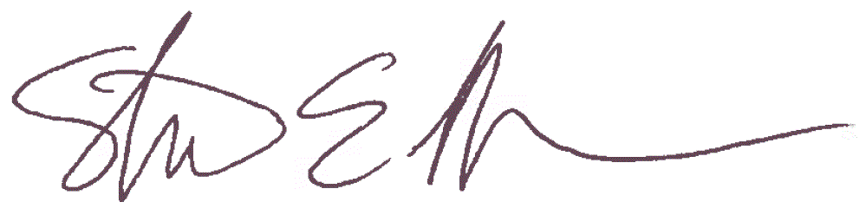
Steven Lieberman
American Municipal Power
Liaison Committee Chair

CC: Mr. Andy Ott, PJM Interconnection, LLC
Mr. Dave Anders, PJM Interconnection, LLC

