June Planning Committee

**Teleconference / WebEx**

June 8, 2021

9:00 a.m. – 12:00 p.m. EPT

Administration (9:00 – 9:10)

1. Welcome, announcements and review of the Anti-trust, Code of Conduct, and Media Participation Guidelines.
2. Approve Planning Committee (PC) Agenda for this meeting.
3. Approve draft minutes from the May 11, 2021 PC meeting.

Endorsements (9:10 – 9:30)

1. 2021 Reserve Requirement Study Assumptions  
   Jason Quevada, PJM, will review the 2021 RRS assumptions as developed in the Resource Adequacy Analysis Subcommittee. The committee will be requested to endorse the study assumptions at today’s meeting.

First Reads (9:30 – 9:45)

1. Manual 14A: New Services Request Process Update  
   Onyinye Caven, PJM, will provide a first read of conforming Manual 14A language for the quick fix of close of queue date and application review timing changes. The committee will be asked to vote on the manual changes at the July meeting.

Informational Updates (9:45 – 10:15)

1. Capacity Interconnection Rights for ELCC Resoures Update

Brian Chmielewski, PJM, will provide an update on work being done during the PC special session on Capacity Interconnection Rights (CIR) for ELCC Resources.

1. Interconnection Process Reform

Jack Thomas, PJM, will provide an update on the Interconnection Process Reform Task Force.

Materials and upcoming meeting dates for task force can be found [here](https://www.pjm.com/committees-and-groups/task-forces/iprtf).

1. Transmission & Substation Subcommittee Update

Jay Liu, PJM, will provide an update on the TSS work activities through 2020 and the first half of 2021 and a work plan for the remainder of the year.

1. Reliability Compliance Update  
   Mark Kuras, PJM, will provide an update on the activities, issues and items of interest at NERC, SERC, and RF.

X. AMP Transmission FERC Form 715 Update

Ed Tatum, AMP Transmission, will provide an update on FERC Form 715 criteria changes.

Working Session (10:15 – 12:00)

1. Critical Infrastructure Stakeholder Oversight Update

Michael Herman, PJM, will lead a discussion on the PC approved Mitigation package, including a review of Operating Agreement language.

Informational Posting

Model Build Activity Update

2021 Series RTEP

* Powerflow
  + PJM staff will internally review the winter and light load cases in June 2021 and work with the Transmission Owners to finalize the cases

2020 Series MMWG

* Dynamics
  + Final 2020 Series MWMG dynamics cases were released and have been and posted to pjm.com

2021 Series MMWG

* Powerflow
  + PowerTech posted the final 2021 winter study case
  + PJM will submit the trial 1 12 cases to PowerTech by June 25, 2021

MOD-032 Update

* The Gen Model window will open May 1 and remain open through June 15. Generator Owners have the option of using data submitted in previous years to prepopulate the 2021 forms; For any questions or comments email [MOD-032@pjm.com](mailto:MOD-032@pjm.com)
* Gen Model link: <https://pjm.com/planning/services-requests/planning-modeling-submission-mod032.aspx>

|  |  |  |  |  |
| --- | --- | --- | --- | --- |
| **Future Meeting Dates and Materials** | | | **Materials Due  to Secretary** | **Materials Published** |
| Date | Time | Meeting (Location) |
| Tuesday, June 8, 2021 | 9:00 a.m. – 12:00 p.m. | Planning Committee (WebEx) | Thursday, May 27, 2021 | Tuesday, June 01, 2021 |
| Tuesday, June 22, 2021 | 9:00 a.m. – 12:00 p.m. | Special PC: CIR for ELCC Resources (WebEx) | Tuesday, June 15, 2021 | Friday, June 18, 2021 |
| Tuesday, June 29, 2021 | 9:00 a.m. – 4:00 p.m. | Interconnection Process Reform Task Force (WebEx) | Monday, June 21, 2021 | Thursday, June 24, 2021 |
| Tuesday, July 13, 2021 | 9:00 a.m. – 12:00 p.m. | Planning Committee (WebEx) | Thursday, July 01, 2021 | Tuesday, July 06, 2021 |
| Monday, July 19, 2021 | 9:00 a.m. – 4:00 p.m. | Interconnection Process Reform Task Force (WebEx) | Friday, July 09, 2021 | Wednesday, July 14, 2021 |
| Thursday, July 22, 2021 | 9:00 a.m. – 12:00 p.m. | Special PC: CIR for ELCC Resources (WebEx) | Wednesday, July 14, 2021 | Monday, July 19, 2021 |
| Tuesday, August 10, 2021 | 9:00 a.m. – 12:00 p.m. | Planning Committee (WebEx) | Thursday, July 29, 2021 | Tuesday, August 03, 2021 |
| Friday, August 13, 2021 | 1:00 p.m. – 4:00 p.m. | Special PC: CIR for ELCC Resources (WebEx) | Thursday, August 05, 2021 | Tuesday, August 10, 2021 |
| Monday, August 23, 2021 | 9:00 a.m. – 4:00 p.m. | Interconnection Process Reform Task Force (WebEx) | Friday, August 13, 2021 | Wednesday, August 18, 2021 |
| Tuesday, August 31, 2021 | 9:00 a.m. – 12:00 p.m. | Planning Committee (WebEx) | Thursday, August 19, 2021 | Tuesday, August 24, 2021 |
| Tuesday, September 21, 2021 | 9:00 a.m. – 12:00 p.m. | Special PC: CIR for ELCC Resources (WebEx) | Tuesday, September 14, 2021 | Friday, September 17, 2021 |
| Tuesday, October 5, 2021 | 9:00 a.m. – 12:00 p.m. | Planning Committee (WebEx) | Thursday, September 23, 2021 | Tuesday, September 28, 2021 |
| Tuesday, November 2, 2021 | 9:00 a.m. – 12:00 p.m. | Planning Committee (WebEx) | Thursday, October 21, 2021 | Tuesday, October 26, 2021 |
| Tuesday, November 30, 2021 | 9:00 a.m. – 12:00 p.m. | Planning Committee (WebEx) | Thursday, November 18, 2021 | Tuesday, November 23, 2021 |

|  |  |  |  |
| --- | --- | --- | --- |
|  |  |  |  |

Author: Molly Mooney

Antitrust:

You may not discuss any topics that violate, or that might appear to violate, the antitrust laws including but not limited to agreements between or among competitors regarding prices, bid and offer practices, availability of service, product design, terms of sale, division of markets, allocation of customers or any other activity that might unreasonably restrain competition. If any of these items are discussed the chair will re-direct the conversation. If the conversation still persists, parties will be asked to leave the meeting or the meeting will be adjourned.

Code of Conduct:

As a mandatory condition of attendance at today's meeting, attendees agree to adhere to the PJM Code of Conduct as detailed in PJM Manual M-34 section 4.5, including, but not limited to, participants' responsibilities and rules regarding the dissemination of meeting discussion and materials.

Public Meetings/Media Participation:

Unless otherwise noted, PJM stakeholder meetings are open to the public and to members of the media. Members of the media are asked to announce their attendance at all PJM stakeholder meetings at the beginning of the meeting or at the point they join a meeting already in progress. Members of the Media are reminded that speakers at PJM meetings cannot be quoted without explicit permission from the speaker. PJM Members are reminded that "detailed transcriptional meeting notes" and white board notes from "brainstorming sessions" shall not be disseminated. Stakeholders are also not allowed to create audio, video or online recordings of PJM meetings. PJM may create audio, video or online recordings of stakeholder meetings for internal and training purposes, and your participation at such meetings indicates your consent to the same.

Participant Identification in WebEx:

When logging into the WebEx desktop client, please enter your real first and last name as well as a valid email address. Be sure to select the “call me” option.

PJM support staff continuously monitors WebEx connections during stakeholder meetings. Anonymous users or those using false usernames or emails will be dropped from the teleconference.

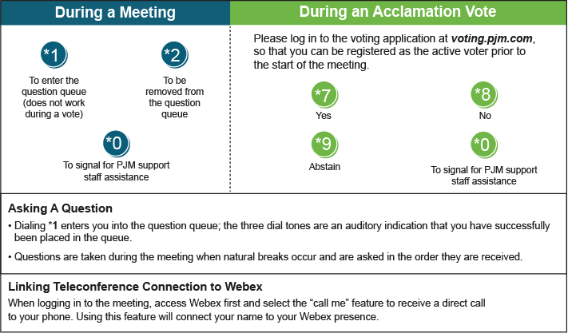

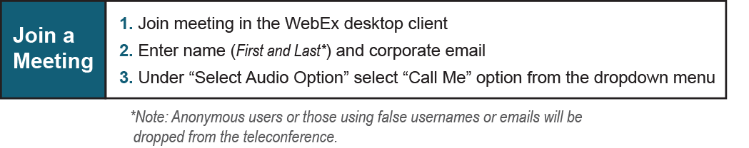

Provide feedback on the progress of this group: *Facilitator Feedback Form*   
Visit [*learn.pjm.com*](http://learn.pjm.com/), an easy-to-understand resource about the power industry and PJM’s role.