April Planning Committee
Teleconference / WebEx
April 6, 2021
9:00 a.m. – 12:00 p.m. EPT

Administration (9:00 – 9:15)
- Welcome, announcements and review of the Anti-trust, Code of Conduct, and Media Participation Guidelines.
- Approve Planning Committee (PC) Agenda for this meeting.
- Approve draft minutes from the March 9, 2021 PC meeting.
- Dave Anders, PJM, will provide an update on the voting protocols for Board elections at the May Members Committee meeting.
- Review the 2021 PC Work Plan

Endorsements (9:15 – 10:15)
- CIR Problem Statement/Issue Charge
Jonathan Kern, PJM, will review a problem statement and issue charge to address the Capacity Interconnection Rights of variable resources. The committee will be asked to approve the issue charge at today’s meeting.

- Interconnection Process Reform
Jason Connell, PJM, will review a problem statement and issue charge to address Interconnection Process Reform. The committee will be asked to approve the issue charge at today’s meeting.

- Interconnection Construction Service Agreement Superseding Language and Automatic Termination Provision
Mark Sims, PJM, will review a problem statement, issue charge and proposed solution to address concerns associated with the pro forma Interconnection Construction Service Agreement’s (a) lack of superseding language and (b) current automatic termination provision. Draft versions of associated Tariff language are posted with meeting materials for informational purposes. The committee will be asked to approve the issue charge and endorse the proposed solution as part of the Quick Fix process outlined in Section 8.6.1 of Manual 34 at the today’s meeting.

First Reads (10:15 – 11:15)
- Manual 14F and Manual 14B Updates
Nick Dumitriu, PJM, will provide a first read of Manual 14F and Manual 14B conforming language for MEPETF capacity driver docket (ER21-162). The committee will be asked to vote on the manual changes at next month’s meeting.

- New Service Requests Deficiency Review Requirements
Jason Connell, PJM, will provide a second first read of a Problem Statement, Issue Charge and proposed solution to address new service requests deficiency review requirements. Draft versions of associated Tariff language are posted with meeting materials for informational purposes. The committee will be asked to approve the issue charge and endorse the proposed solution as part of the Quick Fix process outlined in Section 8.6.1 of Manual 34 at the May PC meeting.

- Manual 21: Rules and Procedures for Determining Generating Capability Update
Jerry Bell, PJM, will provide a first read of Manual 21 regarding the biennial cover to cover review. The committee will be asked to vote on the manual changes at next month’s meeting.

Informational Updates (11:15 – 12:00)
- Manual Updates Regarding Effective Load Carrying Capability (ELCC)
Andrew Levitt, PJM will provide an overview of ELCC and preview updates for Manual 20: PJM Resource Adequacy Analysis, Manual 21: Rules and Procedures for Determination of Generating Capability, and a new Manual 21A: Determination of Accredited UCAP Using Effective Load Carrying Capability Analysis.

- Reliability Compliance Update
Becky Davis, PJM, will provide an update on the activities, issues and items of interest at NERC, SERC, and RF.

- Posting Timeline Trial Period
Michele Greening, PJM, will review information related to a proposed posting timeline trial period.

- Emerging Technologies Forum Survey
Natalie Tacka, PJM, will provide an informational announcement about a forthcoming stakeholder survey related to emerging technologies.

Informational Posting
Model Build Activity Update
2021 Series RTEP
- Powerflow
  - PJM staff will internally review the cases in April 2021 and work with the Transmission Owners to finalize the cases
- Short Circuit
  - Transmission Owners were required to provide their feedback for the Trial 3 2023 case and the Trial 1 2026 case by March 26, 2021; PJM is incorporating the feedback for both cases; Preliminary 2026 results will be sent out within the next several weeks by Transmission Planning
2020 Series MMWG
- Dynamics
  - Pre-final 2020 Series MMWG dynamics cases are expected to be out for review by April 7, 2021; Voting to finalize 2020 Series MMWG dynamics cases expected April 14, 2021; The cases will be posted to PJM.com once they are finalized
2021 Series MMWG
- Powerflow
  - PJM submitted a request for Transmission Owners to update existing projects, upload new projects and update base case in Model-on-Demand by April 2, 2021
  - PJM posted the 1, 2, & 5 year summer cases for topology review on April 5, 2021; Transmission Owners to submit project file updates to Model On Demand based on 1, 2 & 5 year summer cases review by April 16, 2021
  - PJM to request 2021WIN Study Case updates by April 8, 2021; Transmission Owners to provide updates to initial 2021WIN Study Case by April 29, 2021
MOD-032 Update
- The Gen Model window will open May 1 and remain open through June 15. Generator Owners have the option of using data submitted in previous years to prepopulate the 2021 forms; For any questions or comments email MOD-032@pjm.com
- The 2021 yearly updates to the Gen Model Users Guide and MOD-032 Data Requirements Documents will be issued in early April. All applicable contacts on the Gen Model Mailing List will be informed via a separate email when the updated documents are publically available.
- Gen Model link: https://pjm.com/planning/services-requests/planning-modeling-submission-mod032.aspx

Manual 03 Updates
Updates to PJM Manual 03, Revision 59 – Transmission Operations are posted as informational only with meeting materials.
PJM Manual 03 Attachment E Automatic Sectionalizing Schemes
The PJM Manual 03 Attachment E Automatic Sectionalizing Schemes Pending Approval and Recent Changes document has been posted as an Information Only item to the April meeting website.

Future Meeting Dates
Tuesday, April 6, 2021 | 9:00 a.m. – 12:00 p.m. | Planning Committee | WebEx
Tuesday, May 11, 2021 | 9:00 a.m. – 12:00 p.m. | Planning Committee | WebEx
Tuesday, June 8, 2021 | 9:00 a.m. – 12:00 p.m. | Planning Committee | WebEx
Tuesday, July 13, 2021 | 9:00 a.m. – 12:00 p.m. | Planning Committee | TBD
Tuesday, August 10, 2021 | 9:00 a.m. – 12:00 p.m. | Planning Committee | TBD
Tuesday, August 31, 2021 | 9:00 a.m. – 12:00 p.m. | Planning Committee | TBD
Tuesday, October 5, 2021 | 9:00 a.m. – 12:00 p.m. | Planning Committee | TBD
Tuesday, November 2, 2021 | 9:00 a.m. – 12:00 p.m. | Planning Committee | TBD
Tuesday, November 30, 2021 | 9:00 a.m. – 12:00 p.m. | Planning Committee | TBD
Author: Molly Mooney

Antitrust:
You may not discuss any topics that violate, or that might appear to violate, the antitrust laws including but not limited to agreements between or among competitors regarding prices, bid and offer practices, availability of service, product design, terms of sale, division of markets, allocation of customers or any other activity that might unreasonably restrain competition. If any of these items are discussed the chair will re-direct the conversation. If the conversation still persists, parties will be asked to leave the meeting or the meeting will be adjourned.

Code of Conduct:
As a mandatory condition of attendance at today's meeting, attendees agree to adhere to the PJM Code of Conduct as detailed in PJM Manual M-34 section 4.5, including, but not limited to, participants' responsibilities and rules regarding the dissemination of meeting discussion and materials.

Public Meetings/Media Participation:
Unless otherwise noted, PJM stakeholder meetings are open to the public and to members of the media. Members of the media are asked to announce their attendance at all PJM stakeholder meetings at the beginning of the meeting or at the point they join a meeting already in progress. Members of the Media are reminded that speakers at PJM meetings cannot be quoted without explicit permission from the speaker. PJM Members are reminded that "detailed transcriptional meeting notes" and white board notes from "brainstorming sessions" shall not be disseminated. Stakeholders are also not allowed to create audio, video or online recordings of PJM meetings. PJM may create audio, video or online recordings of stakeholder meetings for internal and training purposes, and your participation at such meetings indicates your consent to the same.
Participant Identification in WebEx:
When logging into the WebEx desktop client, please enter your real first and last name as well as a valid email address. Be sure to select the “call me” option.
PJM support staff continuously monitors WebEx connections during stakeholder meetings. Anonymous users or those using false usernames or emails will be dropped from the teleconference.

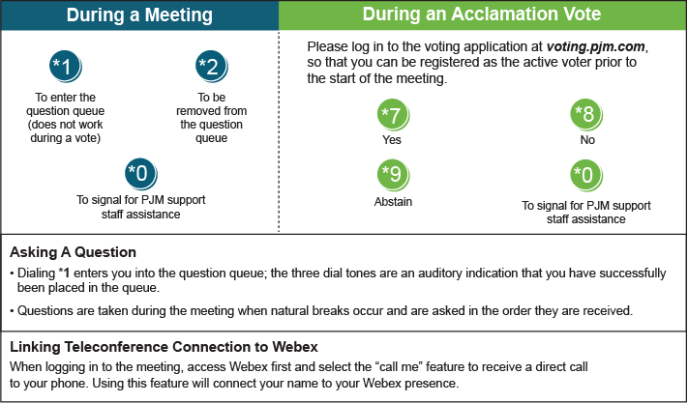

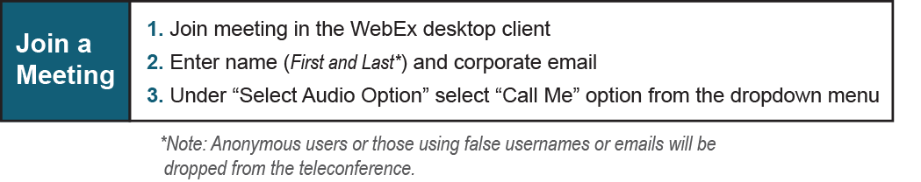

Provide feedback on the progress of this group: Facilitator Feedback Form
Visit learn.pjm.com, an easy-to-understand resource about the power industry and PJM’s role.

