December Planning Committee
Teleconference / WebEx
December 1, 2020
9:00 a.m. – 12:00 p.m. EPT

Administration (9:00 – 9:20)
- Welcome, announcements and review of the Anti-trust, Code of Conduct, and Media Participation Guidelines.
- Approve Planning Committee (PC) Agenda for this meeting
- Approve draft minutes from the November 4, 2020 PC meeting
- Natasha Holter, PJM, will update the committee on a poll from the Emerging Technologies Forum (ETF) to gauge stakeholder interest on topics that should be discussed at that group.

Endorsements (9:20 –10:00)
- Planning Committee Charter
David Souder, PJM, will review the Planning Committee Charter. No changes have been made to the Planning Committee Charter. The committee will be asked to endorse the Charter at today’s meeting.

- Storage As Transmission Asset Update
Michele Greening, PJM, will review work done at the Storage As Transmission Asset Special Planning Committee sessions. Jeffrey Goldberg, PJM, will review PJM’s package. A draft version of associated OA language is posted with meeting materials for informational purposes. The committee will be asked to endorse the package at today’s meeting.
Issue Tracking: Storage As a Transmission Asset

First Reads (10:00 – 10:45)
- Critical Infrastructure Stakeholder Update
- Christina Stotesbury, PJM, will review work done at the Critical Infrastructure Stakeholder Oversight sessions.
- PJM Legal will review the details of FERC Docket No ER20-841-001 “Order Addressing Arguments Raised on Rehearing” dated November 19, 2020
- Mike Herman, PJM, will review the PJM proposal to address Avoidance of future CIP-014 facilities, including a first read of associated manual language.
- David Souder, PJM, will discuss CISO next steps.
Issue Tracking: Critical Infrastructure Stakeholder Oversight

Informational Updates (10:45 – 12:00)
- Recent Load Impacts and Preliminary 2021 Load Forecast
A. Andrew Gledhill, PJM, will present the estimated Covid-19 impacts on recent loads.
B. Andrew Gledhill, will review the preliminary 2021 Load Forecast results.
- New Jersey BPU State Agreement Approach
NJBPU staff, will discuss the November 18, 2020 Clean Energy Order (Docket No. QO20100630) declaring transmission to support offshore wind a public policy of the state of New Jersey.
- State Agreement Approach
Mark Sims, PJM, will continue education on the PJM State Agreement Approach.

- Transmission & Substation Subcommittee Update
Jay Liu, PJM, will provide an update on the Transmission & Substation Subcommittee (TSS) work activities through 2020.

- Reliability Compliance Update
Mark Kuras, PJM, will provide an update on the activities, issues and items of interest at NERC, SERC, and RF.

Informational Posting
Model Build Activity Update
2020 Series MMWG
- Powerflow – final cases have been reviewed and approved
2021 Series RTEP
- Powerflow – PJM builds and delivers Trial 2 cases to the Transmission Owners by Friday December 11, 2020; Transmission Owners to submit their Trial 2 updates by Wednesday January 6, 2021
- Short Circuit – PJM is currently building the Trial 1 2023 case, it will be sent to the Transmission Owners for review in early January 2021
Update on 2021 Generator Model Window
Posted with materials for the December PC is a document describing 2021 Gen Model updates. New data requested is described in the document. The Gen Model window will open on 5/1/21 and end on 6/15/21.

Friday, December 11, 2020 | 9:00 a.m. – 4:00 p.m. | Interconneciton Process Workshop 2 | WebEx
Monday, January 11, 2021 | 9:00 a.m – 12:00 p.m. | Planning Committee | WebEx
Tuesday, February 9, 2021 | 9:00 a.m – 12:00 p.m. | Planning Committee | WebEx
Tuesday , March 9, 2021 | 9:00 a.m – 12:00 p.m. | Planning Committee | WebEx
Tuesday, April 6, 2021 | 9:00 a.m – 12:00 p.m. | Planning Committee | WebEx
Tuesday, May 11, 2021 | 9:00 a.m – 12:00 p.m. | Planning Committee | WebEx
Tuesday, June 8, 2021 | 9:00 a.m – 12:00 p.m. | Planning Committee | WebEx
Tuesday, July 13, 2021 | 9:00 a.m – 12:00 p.m. | Planning Committee | PJM Conference & Training Center/ WebEx
Tuesday, August 10, 2021 | 9:00 a.m – 12:00 p.m. | Planning Committee | PJM Conference & Training Center/ WebEx
Wednesday, September 8, 2021 | 9:00 a.m – 12:00 p.m. | Planning Committee | PJM Conference & Training Center/ WebEx
Tuesday, October 5, 2021 | 9:00 a.m – 12:00 p.m. | Planning Committee | PJM Conference & Training Center/ WebEx
Tuesday, November 2, 2021 | 9:00 a.m – 12:00 p.m. | Planning Committee | PJM Conference & Training Center/ WebEx
Tuesday, Noember 30, 2021 | 9:00 a.m – 12:00 p.m. | Planning Committee | PJM Conference & Training Center/ WebEx
Author: Molly Mooney

Antitrust:
You may not discuss any topics that violate, or that might appear to violate, the antitrust laws including but not limited to agreements between or among competitors regarding prices, bid and offer practices, availability of service, product design, terms of sale, division of markets, allocation of customers or any other activity that might unreasonably restrain competition. If any of these items are discussed the chair will re-direct the conversation. If the conversation still persists, parties will be asked to leave the meeting or the meeting will be adjourned.

Code of Conduct:
As a mandatory condition of attendance at today's meeting, attendees agree to adhere to the PJM Code of Conduct as detailed in PJM Manual M-34 section 4.5, including, but not limited to, participants' responsibilities and rules regarding the dissemination of meeting discussion and materials.

Public Meetings/Media Participation:
Unless otherwise noted, PJM stakeholder meetings are open to the public and to members of the media. Members of the media are asked to announce their attendance at all PJM stakeholder meetings at the beginning of the meeting or at the point they join a meeting already in progress. Members of the Media are reminded that speakers at PJM meetings cannot be quoted without explicit permission from the speaker. PJM Members are reminded that "detailed transcriptional meeting notes" and white board notes from "brainstorming sessions" shall not be disseminated. Stakeholders are also not allowed to create audio, video or online recordings of PJM meetings. PJM may create audio, video or online recordings of stakeholder meetings for internal and training purposes, and your participation at such meetings indicates your consent to the same.
Participant Identification in WebEx:
When logging into the WebEx desktop client, please enter your real first and last name as well as a valid email address. Be sure to select the “call me” option.
PJM support staff continuously monitors WebEx connections during stakeholder meetings. Anonymous users or those using false usernames or emails will be dropped from the teleconference.

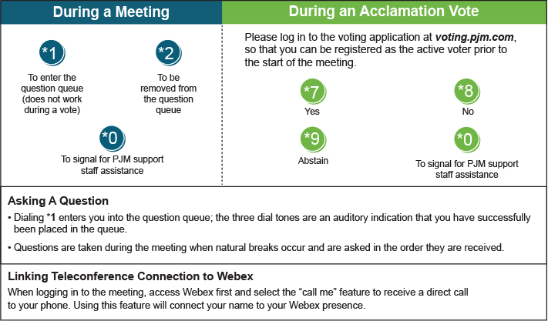

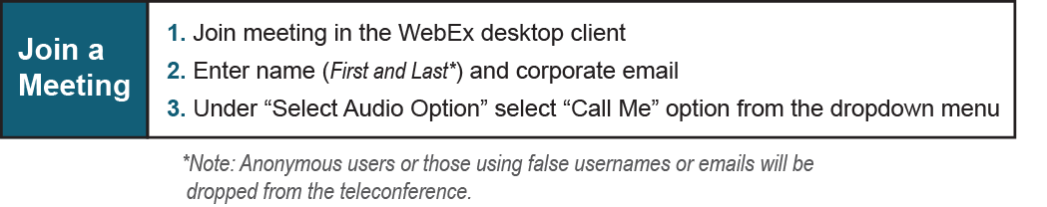

Provide feedback on the progress of this group: Facilitator Feedback Form
Visit learn.pjm.com, an easy-to-understand resource about the power industry and PJM’s role.

