Special Planning Committee – Consideration of Cost Commitment for Evaluation of Competitive Transmission Proposals
PJM Conference and Training Center
March 6, 2018
1:00 p.m. – 4:00 p.m. EPT

Administration (1:00-1:05)
Ms. Laura Walter, PJM, will provide announcements; review the Antitrust, Code of Conduct, Public Meetings/Media Participation Guidelines and WebEx identification guidelines. The committee will be asked to approve the draft minutes from the February 9, 2018 meeting.
Order 1000 Lessons Learned Issue Tracking

Education (1:05-2:45)
Ms. Sue Glatz, PJM will review of Order 1000 language related to cost containment
Mr. Jason Shoemaker, PJM, will present education on competitive transmission models
Ms. Sharon Segner, LS Power, will present two proposed Analytical Framework Templates. Stakeholder feedback on these templates is requested in advance of the March 16 meeting.
#1: An Evaluation Template for Assessing the Quality and Legal Enforceability of the Cost Containment Proposal
#2: An Evaluation Template for Reviewing a Construction Cost Cap Proposal

Mr. Jay Liu, PJM will present an overview of the project implementation process (Manual 14C).
Mr. Jason Shoemaker will present draft topics on rate analysis; education to be presented at March 16 meeting.

CBIR Process (2:55-3:55)
Ms. Fabiano, PJM, will continue a discussion to review and gather additional stakeholder interests. Pre-prepared interests can be provided in advance of the meeting (email to laura.walter@pjm.com) or during the meeting. If not provided in advance, stakeholders should come with interests ready to share during the meeting.
The purpose of this step is to ensure that all stakeholders have a common understanding of each other’s interests vis-à-vis their potential positions on individual issues (interests and positions are different – positions are assertions about what people say they want, while interests are why people want what they want (needs, motivations, concerns, and desires behind the position) –Manual 34, Section 7.2(2)
- Ms. Fabiano will ask the committee to engage in design component development and brainstorming of solution components. Additional design components can be provided in advance of the meeting (email to: laura.walter@pjm.com) or during the meeting.

Future Agenda Items (3:55-4:00)
Participants will have the opportunity to request the addition of any new item(s) to the agenda of a future meeting.

Future Meeting Dates
March 16, 2018 | 1:00 p.m. | PJM Conference & Training Center/ WebEx
April 3, 2018 | 1:00 p.m. | PJM Conference & Training Center/ WebEx
April 27, 2018 | 9:00 a.m. | Conference Call/ WebEx
Author: Laura Walter

Antitrust:
You may not discuss any topics that violate, or that might appear to violate, the antitrust laws including but not limited to agreements between or among competitors regarding prices, bid and offer practices, availability of service, product design, terms of sale, division of markets, allocation of customers or any other activity that might unreasonably restrain competition. If any of these items are discussed the chair will re-direct the conversation. If the conversation still persists, parties will be asked to leave the meeting or the meeting will be adjourned.

Code of Conduct:
As a mandatory condition of attendance at today's meeting, attendees agree to adhere to the PJM Code of Conduct as detailed in PJM Manual M-34 section 4.5, including, but not limited to, participants' responsibilities and rules regarding the dissemination of meeting discussion and materials.

Public Meetings/Media Participation:
Unless otherwise noted, PJM stakeholder meetings are open to the public and to members of the media. Members of the media are asked to announce their attendance at all PJM stakeholder meetings at the beginning of the meeting or at the point they join a meeting already in progress. Members of the Media are reminded that speakers at PJM meetings cannot be quoted without explicit permission from the speaker. PJM Members are reminded that "detailed transcriptional meeting notes" and white board notes from "brainstorming sessions" shall not be disseminated. Stakeholders are also not allowed to create audio, video or online recordings of PJM meetings. PJM may create audio, video or online recordings of stakeholder meetings for internal and training purposes, and your participation at such meetings indicates your consent to the same.
Participant Identification in WebEx:
When logging into the WebEx desktop client, please enter your real first and last name as well as a valid email address. Be sure to select the “call me” option.
PJM support staff continuously monitors WebEx connections during stakeholder meetings. Anonymous users or those using false usernames or emails will be dropped from the teleconference.

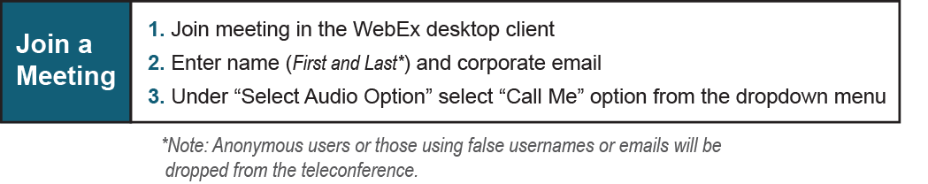
Provide feedback on the progress of this group: Facilitator Feedback Form
Visit learn.pjm.com, an easy-to-understand resource about the power industry and PJM’s role.

