Operating Committee
WebEx Only
March 10, 2022
9:00 a.m. – 2:00 p.m. EST

Administration (9:00-9:15)
Lauren Strella Wahba, PJM, will provide announcements; review the Antitrust, Code of Conduct, Public Meetings/Media Participation, and the WebEx Participant Identification Requirement.
  - Review and approve draft minutes from the February 10th OC meeting.

  - Review and approve the draft minutes from the February 22nd OC Special Session: Renewable
Dispatch meeting.

  - Review and approve the draft minutes from the February 25th OC Special Session: Dynamic
Rating.

  - Review of the OC work plan.

Review of Operations (9:15-9:20)
Review of Operating Metrics
Mike Zhang, PJM, will review the February 2022 PJM operating metrics slides. Metrics will include PJM’s load forecast error, BAAL performance, and transmission / generation outage statistics.

Endorsements/Approvals (9:20-9:50)
Action Required: Members are reminded to complete the necessary steps to update their browser prior to the meeting to avoid impact to Voting Application access. Reference: Weak Encryption

- Manual 12: Balancing Operations
Brian Oakes, PJM, will review Manual 12 changes as a part of the periodic review.
The Operating Committee will be asked to endorse these changes at today’s meeting.

- Manual 13: Emergency Operations
Brian Oakes, PJM, will review Manual 13 changes as a part of the periodic review.
The Operating Committee will be asked to endorse these changes at today’s meeting.

- Manual 37: Reliability Coordination
Kevin Hatch, PJM, will review Manual 37 changes as a part of the periodic review.
The Operating Committee will be asked to endorse these changes at today’s meeting.

First Reading (9:50-10:50)
- Dynamic Rating Issue
  - Chris Callaghan, PJM, will provide a first read of the Interim Measures to Facilitate the Integration
of PPL Dynamic Ratings into PJM Operations (Phase 1) Issue Charge and Problem Statement.
Bilge Derin, PJM, will provide a review of changes to M03: Transmission Operations, M03A:
Energy Management System (EMS) Model Update and Quality Assurance (QA), and M01: Control
Center and Data Exchange Requirements.
The Operating Committee will be asked to approve the issue charge and endorse the
proposed solution as part of the Quick Fix process outlined in Section 8.6.1 of Manual 34 at
its next meeting.

  - Chris Callaghan, PJM, will provide a first read of the Additional Issues Relating to the
Implementation of Dynamic Line Ratings (Phase 2) Issue Charge and Problem Statement.
The Operating Committee will be asked to approve the Issue Charge at its next meeting.

- Manual 01: Control Center and Data Exchange Requirements
Bilge Derin, PJM, will review Manual 01 changes as a part of the periodic review.
The Operating Committee will be asked to endorse these changes at its next meeting.

- Documenting the Appropriate UFLS Requirements Applicable to EKPC
Denise Foster Cronin, EKPC, will provide a first read of a Problem Statement and Issue Charge to appropriately document the underfrequency relay requirements applicable to EKPC. The Operating Committee will be asked to approve the Issue Charge and endorse the proposed solution at its next meeting as part of the Quick Fix process outlined in Section 8.6.1 of Manual 34. The MRC and MC will ultimately be asked to endorse/approve the solution and corresponding OA revisions.

- Reliability Products and Services Assessment
Chris Pilong and Alex Scheirer, PJM, will provide a first read of a proposed "initial direction" regarding reliability products and services as required by the Resource Adequacy Sr. Task Force Charter.
RASTF Website
The Operating Committee will be asked to approve the initial recommendation at its next
meeting.

Additional Items (10:50-12:00)
- Lanexa – Dunnsville Outage Coordination Review
Paul McGlynn, PJM, will provide an overview of the outage coordination process for the Lanexa – Dunnsville 230 kV line outage in the Dominion transmission zone.

- Transmission Outage Scheduling Process
Paul McGlynn, PJM, will review existing generation and transmission outage scheduling and coordination processes and procedures and discuss some potential improvement opportunities and next steps.

- Managing Transmission Line Ratings Order No. 881 Compliance Filing (RM20-16-000) Update
David Hislop, PJM, and Bilge Derin, PJM, will provide an informational update regarding PJM’s FERC Order No. 881 compliance efforts relating to ambient adjusted ratings. PJM continues to provide updates and solicit stakeholder input at Operating Committee meetings as it prepares its compliance filing, which is due July 12, 2022.

- PPL Dynamic Line Rating Implementation Update
Dave Hislop, PJM, will provide an update on the implementation of the PPL Dynamic Line Rating.

- Informational Update on the Max Emergency Changes “Quick Fix Process” to Manual 13
Chris Pilong, PJM, will provide an informational update on the proposed changes to Manual 13 regarding addressing the extension of a temporary change to Max Emergency for gas combustion turbines and steam generators using the Quick Fix Process.

- Fast Start Capable Request Process
Vijay Shah, PJM, will review the process to become fast start capable resource.

- Synchronous Reserve Event Actions and Expectations Update
Ilyana Dropkin, PJM, will provide and update on the SRDTF activities.
SRDTF Website

- 2022 PJM Grid Security Drill Announcement
Ed Figuli, PJM, will provide an announcement regarding the coordination of this year’s PJM Grid Security Drill.

- TO/TOP Matrix Subcommittee Charter Review
Gizella Mali, PJM, will review the latest revisions to the TTMS Charter.

- System Operations Subcommittee (SOS) Report
Donnie Bielak, PJM, will provide a summary of the most recent SOS meeting.

- Primary Frequency Response Update
Ilyana Dropkin, PJM, will provide an update on PJM primary frequency response performance.

- Regulation Performance Update
Ilyana Dropkin, PJM, will provide an update on PJM regulation market performance.

- Synchronous Reserve Update
Dave Kimmel, PJM, will provide a review of recent synchronous reserve performance.

- Reliability Compliance Update
Becky Davis, PJM, will provide an update on NERC, SERC, RF, and NAESB standards, and other pertinent regulatory and compliance information, and solicit feedback from the members on Reliability Compliance efforts.

LUNCH (12:00 – 12:30)

Working Items (12:30-2:00)
- IROL-CIP Cost Recovery
Darlene Phillips, PJM, will facilitate a discussion to review and identify additional design components on the IROL-CIP Cost Recovery matrix as part of the Consensus Based Issue Resolution process.
Issue Tracking: IROL-CIP Cost Recovery

- Renewable Dispatch
  - Guillermo Bautista Alderte, CAISO, will provide education on CAISO’s experience with wind
and solar dispatch.

  - Darlene Phillips, PJM, will facilitate a discussion to review and identify additional interests on the
Renewable Dispatch matrix as part of the Consensus Based Issue Resolution process.
Issue Tracking: Renewable Dispatch

Informational Only Postings

OC Subcommittee/ Task Force Informational Section
System Operations Subcommittee (SOS): SOS Website
Data Management Subcommittee (DMS): DMS Website
DER & Inverter-Based Resources Subcommittee (DIRS): DIRS Website
Fuel Requirements for Black Start Resources: Fuel Reqt. for Black Start Resources Issue Tracker
Synchronous Reserve Deployment Task Force: SRDTF Website
IROL – CIP Cost Recovery: IROL – CIP Cost Recovery Issue Tracker

Future Meeting Dates and Materials |  |  | Materials Due  to Secretary | Materials Published
Date | Time | Location | 5 p.m. | 4 p.m.
April 14, 2022 | 9 a.m. | WebEx | April 4, 2022 | April 7, 2022
May 12, 2022 | 9 a.m. | WebEx | May 2, 2022 | May 5, 2022
June 9, 2022 | 9 a.m. | WebEx | May 30, 2022 | June 2, 2022

Author: L. Strella Wahba

Antitrust:
You may not discuss any topics that violate, or that might appear to violate, the antitrust laws including but not limited to agreements between or among competitors regarding prices, bid and offer practices, availability of service, product design, terms of sale, division of markets, allocation of customers or any other activity that might unreasonably restrain competition. If any of these items are discussed the chair will re-direct the conversation. If the conversation still persists, parties will be asked to leave the meeting or the meeting will be adjourned.

Code of Conduct:
As a mandatory condition of attendance at today's meeting, attendees agree to adhere to the PJM Code of Conduct as detailed in PJM Manual M-34 section 4.5, including, but not limited to, participants' responsibilities and rules regarding the dissemination of meeting discussion and materials.
Public Meetings/Media Participation:
Unless otherwise noted, PJM stakeholder meetings are open to the public and to members of the media. Members of the media are asked to announce their attendance at all PJM stakeholder meetings at the beginning of the meeting or at the point they join a meeting already in progress. Members of the Media are reminded that speakers at PJM meetings cannot be quoted without explicit permission from the speaker. PJM Members are reminded that "detailed transcriptional meeting notes" and white board notes from "brainstorming sessions" shall not be disseminated. Stakeholders are also not allowed to create audio, video or online recordings of PJM meetings. PJM may create audio, video or online recordings of stakeholder meetings for internal and training purposes, and your participation at such meetings indicates your consent to the same.
Participant Identification in WebEx:
When logging into the WebEx desktop client, please enter your real first and last name as well as a valid email address. Be sure to select the “call me” option.
PJM support staff continuously monitors WebEx connections during stakeholder meetings. Anonymous users or those using false usernames or emails will be dropped from the teleconference.

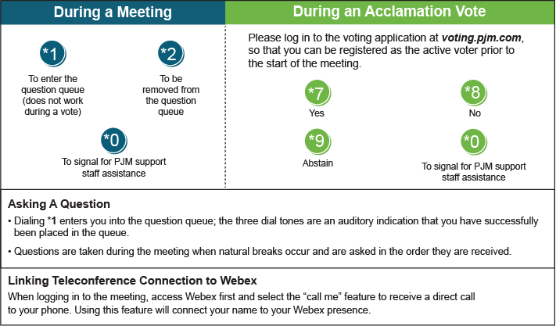

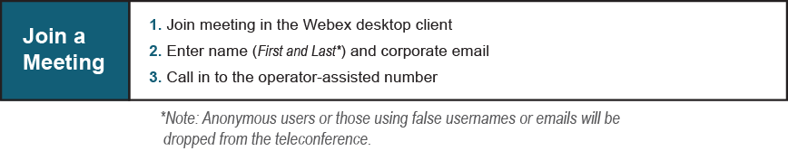
Provide feedback on the progress of this group: Facilitator Feedback Form
Visit learn.pjm.com, an easy-to-understand resource about the power industry and PJM’s role.

